Batch: B2 Roll No.: 1611103

Experiment / assignment / tutorial No._____

Grade: AA / AB / BB / BC / CC / CD /DD

Signature of the Staff In-charge with date

TITLE: Study of PCI and SCSI.

AIM: To Study and learn PCI and SCSI
______________________________________________________________________
Expected OUTCOME of Experiment:

CO 1- Describe and define the structure of a computer with buses structure.
_____________________________________________________________________
Books/ Journals/ Websites referred:

- https://www.techopedia.com/definition/8815/peripheral-component-interconnect-bus-pci-bus
- https://www.techopedia.com/definition/331/small-computer-system-interface-scsi
- http://www.csun.edu/~edaasic/roosta/BUS_Structures.pdf
- W.Stallings William “Computer Organization and Architecture: Designing for Performance”, Pearson Prentice Hall Publication, 7thEdition. C.
Pre Lab/ Prior Concepts:
Microcomputer buses which communicate with a peripheral devices or a memory location through communication lines called buses.
The major parts of microcomputers are central processing unit (CPU), memory, and input and output unit. To connect these parts together through three sets of parallel lines, called buses. These three buses are Address bus, data bus, and Control bus.

Address Bus:
The address bus consists of 16, 20, 24, or more parallel signal lines, through which the CPU sends out the address of the memory location. This memory location is used for to written to or read from. The number of memory location is depends on 2 to the power N address lines. Example, a CPU with 16 address lines can address 216 or 65,536 memory locations. When the CPU reads data from or writes data to a port. The port address is also sent out on the address bus. This is unidirectional. This means that the CPU can send data to a memory location or I/O ports.

Data Bus:
The data bus consists of 8, 16, 32 or more parallel signal lines. The data bus lines are bidirectional. This means that the CPU can read data from memory or from a I/O port as well as send data to a memory location or to a I/O port. In a system, many output devices are connected to the data bus, but only one device at a time will be enabled to the output.

Control Bus:
The control bus consists of 4-10 parallel signal lines. The CPU sends out signals on the control bus to enable the outputs of addressed memory devices or port devices. Typically control bus signals are memory read, memory write, I/O read and I/O write. To read a data from a memory location, the CPU sends out the address of the desired data on the address bus and then sends out a memory read signal on the control bus. The memory read signal enables the addressed memory device to output the data onto the data bus where it is read by the CPU.

PCI Bus:
Peripheral Component Interconnect (PCI), as its name implies is a standard that describes how to connect the peripheral components of a system together in a structured and controlled way. The standard describes the way that the system components are electrically connected and the way that they should behave.
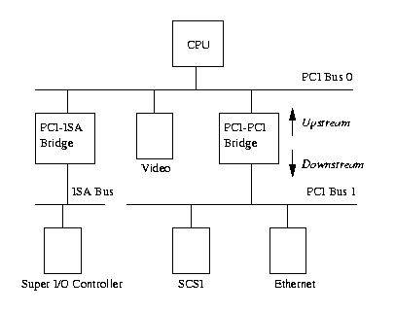
PCI Based System
The figure above is a logical diagram of an example PCI based system. The PCI buses and PCI-PCI bridges are the glue connecting the system components together; the CPU is connected to PCI bus 0, the primary PCI bus as is the video device. A special PCI device, a PCI-PCI bridge connects the primary bus to the secondary PCI bus, PCI bus1. In the jargon of the PCI specification, PCI bus 1 is described as being downstream of the PCI-PCI bridge and PCI bus 0 is upstream of the bridge. Connected to the secondary PCI bus are the SCSI and Ethernet devices for the system. Physically the bridge, secondary PCI bus and two devices would all be contained on the same combination PCI card. The PCI-ISA bridge in the system supports older, legacy ISA devices and the diagram shows a super I/O controller chip, which controls the keyboard, mouse and floppy.
Peripheral devices have their own memory spaces. The CPU can access these spaces but access by the devices into the system's memory is very strictly controlled using DMA (Direct Memory Access) channels. PCI has three components PCI I/O, PCI Memory and PCI Configuration space. All of these address spaces are also accessible by the CPU with the PCI I/O and PCI Memory address spaces being used by the device drivers and the PCI Configuration space being used by the PCI initialization code.
SCSI bus:
A small computer systems interface (SCSI) is a standard interface for connecting peripheral devices to a PC. Depending on the standard, generally it can connect up to 16 peripheral devices using a single bus including one host adapter. SCSI is used to increase performance, deliver faster data transfer transmission and provide larger expansion for devices such as CD-ROM drives, scanners, DVD drives and CD writers. SCSI is also frequently used with RAID, servers, high-performance PCs and storage area networks. SCSI has a controller in charge of transferring data between the devices and the SCSI bus. It is either embedded on the motherboard or a host adapter is inserted into an expansion slot on the motherboard. The controller also contains SCSI basic input/output system, which is a small chip providing the required software to access and control devices. Each device on a parallel SCSI bus must be assigned a number between 0 and 7 on a narrow bus or 0 and 15 on a wider bus. This number is called an SCSI ID. Newer serial SCSI IDs such as serial attached SCSI (SAS) use an automatic process assigning a 7-bit number with the use of serial storage architecture initiators.

Conclusion:

Post Lab Descriptive Questions (Add questions from examination point view)
Q1. Differentiate between PCI and SCSI Bus

PCI bus was created by Intel in 1993. PCI bus can transfer 32 or 64 bits at one time. PCI bus ran originally at 33 Mhz, with a data transfer of 250 Mbytes/s. PCI Express is used with modern graphics cards at 1 gbyte/s (or more), also network cards.

SCSI is a high performance 16-bit bus which is used for fast disks, scanners, and for devices which require high bandwidth. It has a data rate of 640 MB/s.

Peripheral Component Interconnect (PCI), as its name implies is a standard that describes how to connect the peripheral components of a system together in a structured and controlled way.

SCSI is standard electronic interfaces that allow personal computers to communicate with peripheral hardware such as disk drives, tape drives etc.

PCI :
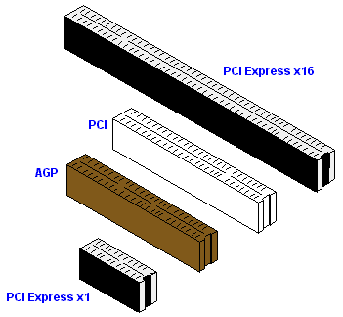
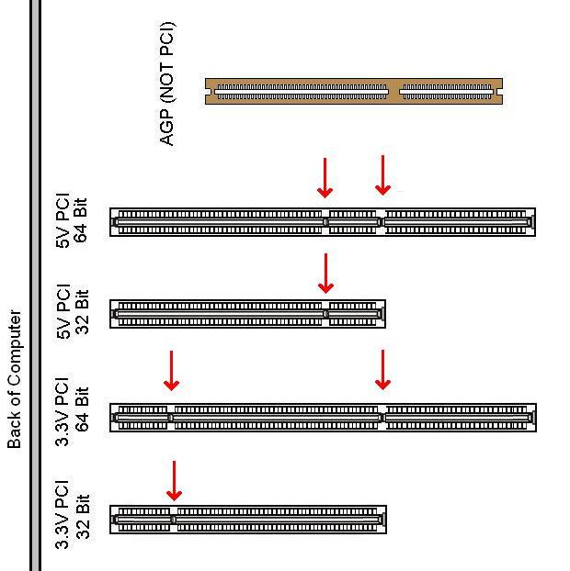

SCSI:
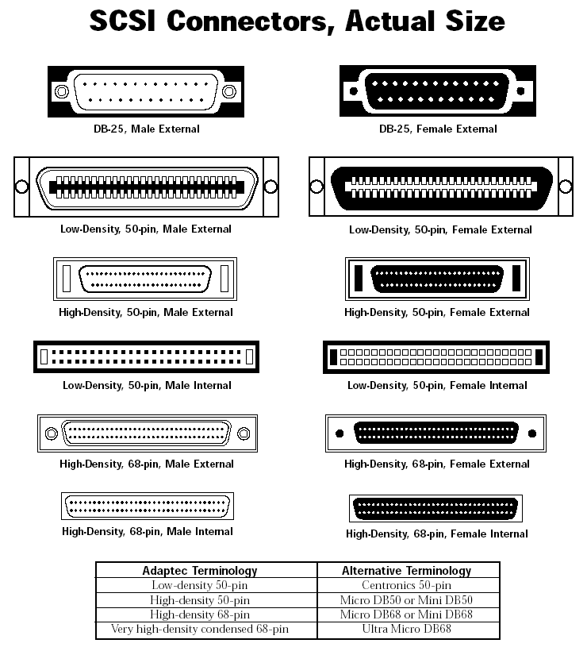

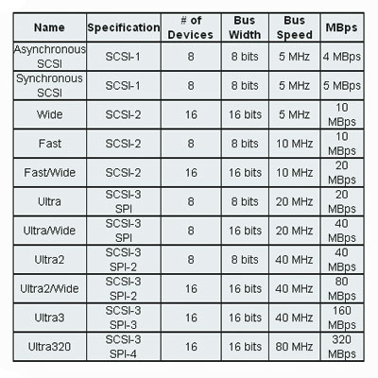

Q2. List the application of PCI and SCSI Bus

PCI:
- PCI was immediately put to use in servers, replacing MCA and EISA as the server expansion bus of choice.
- Typical PCI cards used in PCs include: network cards, sound cards, modems, extra ports such as USB or serial, TV tuner cards and disk controllers. PCI video cards replaced ISA and VESA cards until growing bandwidth requirements outgrew the capabilities of PCI.
- RAM chips, graphic cards and many more.
SCSI:
- SCSI is most commonly used for hard disk drives and tape drives, but it can connect a wide range of other devices, including scanners and CD drives, although not all controllers can handle all devices.
- A SCSI controller, also called a host bus adapter (HBA), is a card or chip that allows storage device to communicate with the operating system across a SCSI bus.

Date: Signature of faculty in-charge

